Question 1
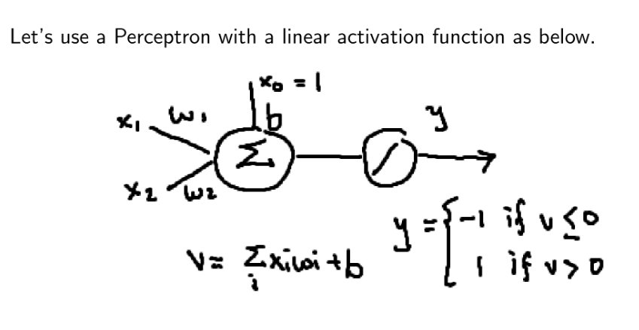

Set w1 = 1, w2 =1 and b=-1.

- Write out the equation for the summation function v including the expanded version of the equation.
- Complete the table below

x1 | x2 | V (activation function) | y(output)
-1 | -1
-1 | 1
1 | -1
1 | 1

- Plot the input (x1,x2) against output y.
- This network architecture functions as one of the LOGIC operators. Which one?

Question 2

Why do we need an activation function?

